Sean Finnegan
POLS 8003: Political Statistics 2
Dr. Arceneaux
May 4, 2020
Income and Legislative Effectiveness: The Case of the U.S. Congress
In recent years, the left wing of the Democratic Party has begun to reemerge as a vocal voice on the national political stage. This resurgence has brought the issue of economic inequality to the fore of the national conversation, as this is an issue of key importance to this ideological constituency. Following this interest, there have been many articles written about the link between constituent preferences and legislator behavior with many studying legislator responsiveness depending on the economic status of voters in their constituency. In this paper, I will study the link between the average income of a constituency and their legislators’ ability to pass legislation in congress. My research question is as follows: Does the average median income of the districts represented by congressional party caucuses affect that caucus’s ability to pass legislation? Currently there is research on individual representatives’ responsiveness to their own constituents based on the income of their constituents, but there has been less research on the link between income and legislative effectiveness. Drawing on existing scholarship as well as census data and congressional vote data provided by UCLA, I hypothesize that a congressional caucus from higher income districts will have an easier time passing their constituents’ preferred legislation. This is because politicians are more often high-income themselves, the high cost of campaigns, and because high-income citizens have a higher capacity to participate in the political process. Ultimately, I find very mild evidence that the average median income of a congressional majority increases that majority’s effectiveness.
Joseph Daniel Ura and Christopher R. Ellis (2008) in the article “Income, Preferences, and the Dynamics of Policy Responsiveness”, discuss the rising income inequality in the United States and its result in the “representative failure hypothesis” which states that “disparities in participation ensure that ordinary Americans speak in a whisper while the most advantaged roar.” They then test this hypothesis using time series data. Through their research they find that there are subtle systematic differences in policy preferences across income cohorts, but that legislators tend to respond equally to all groups (Ura and Ellis 2008). However, if there are differences between income groups, then legislators have to pick one policy position over the other at specific times, so one group will win out over the other.
Answering the question “Who’s preferences do legislators take into account?” is essential to a study of what affects legislators’ voting behavior. In an article entitled “Beyond the Median: Voter Preferences, District Heterogeneity, and Political Representation”, the authors consider this question in order to better understand political representation in the United States (Lewis and Gerber 2004). Moreover, many districts in the United States are very heterogeneous with regard to their political preferences. So the authors “use a unique data set to estimate the distribution of voter preferences within legislative districts” and find that median preferences are a better predictor of legislator voting record in politically homogeneous district than in heterogeneous ones (Lewis and Gerber 2004). Knowing this, we also know that representatives from heterogeneous districts are more susceptible to party pressures because they rely on their party more heavily. In other words, representatives from heterogeneous districts are less likely to take into account the preferences of their constituents.
Similar results were found by Larry Bartels in Unequal Democracy where he found that the richest third of the population is much better represented in congress than the rest of the country. However, Yosef Bhatti and Robert Erikson (2011) set out to reexamine his claim and came out with more muddled findings, though they were not able to definitively disprove Bartels’ claims. A major problem that they encountered was multicollinearity which was caused by high correlation between the preferences of different income groups. They find that since there is high correlation between these groups’ preferences, there is little point in comparing general ideology between different income groups and recommend that research look more into specific domestic policy issues (Bhatti and Erikson 2011).
In their paper “Does Less Income Mean Less Representation?” Brunner et al. (2012) argue that “less income does not mean less representation”. They use data from California’s ballot measures to study the similarity between the way legislators and their constituents vote because the legislators and voters voted on the same proposal. From these measures they recorded how the legislators voted, how the poor neighborhoods voted, and how the rich neighborhoods voted. They use these variables to see how often legislators vote with each income group and whether they favor one group over the other when income groups have different opinions on legislation. The preferences of the two income groups turn out to be highly correlated so legislators vote with the majority of their constituents most of the time. However, they find that whether a legislator votes with their low income or high income constituents more often depends on the party of that legislator. For example, they find that Democratic elected officials vote with their low income constituents more often and Republicans vote with their high income constituents more often. To prove that legislators respond to the will of their constituents rather than voters following the lead of their representatives, they find that “when asked directly voters do not name their representatives as being influential in their proposition voting” and posit that voters are unlikely to know how their representatives voted on a particular proposition (Brunner et al. 2012).
This article looks distinctly at the link between income-based preferences and legislator responsiveness because it captures the rare case where legislators and voters are voting on the same propositions, often with the exact same wording. An important point to note is that although they do not find a general preference to represent the high income voters among legislators, there is a notable difference based on party. This suggests that any study of economic class and political representation should make a distinction between parties because they are likely to favor different kinds of legislation regardless of income.
Chris Tausanovitch (2016) has also studied a similar issue in his article “Income, Ideology, and Representation”. The main purpose of the article is to “test the hypothesis of differential representation in the U.S. House of Representatives and the U.S. Senate” (Tausanovitch 2016). He finds that there is a strong relationship between high income constituents and legislator behavior specifically in the U.S. Senate. This paper discusses the fact that income groups are hard to separate statistically at a national level given the fact that legislator positions are more homogenous within parties and heterogenous between parties (Tausanovitch 2016). Because there is more variation between parties than within parties, legislators may not be bound by the economic interests of their own constituents. Instead, legislator behavior may be more likely to follow the preferences of the majority of their party in the congress. This demonstrates that legislators are willing to focus on things other than their constituents’ preferences when acting on legislation. To take this situation as an example, a district may be a safe district for a certain party. Therefore, the elected official representing this district is willing to exhibit party loyalty even if it may go against some of their constituents’ preferences in specific instances because party loyalty leads to personal benefits for legislators.
In the following sections I analyze congressional majorities and minorities in the United States House of Representatives and Senate. I specifically study the relationship between the average of the median incomes of all districts represented by a party’s caucus in a certain chamber of congress and that caucus’ ability to pass legislation in their own chamber controlling for other variables that may affect the passage of legislation.
Hypothesis 1: Legislators coming from high income districts will advocate for legislation that benefits higher income people, therefore, they are more likely to gather enough votes because politicians are often well off economically.
This hypothesis rests on the assumption that legislators do not always consider their constituents’ preferences when making decisions on whether to support or oppose a piece of legislation. High income politicians may be willing to support legislation like this even if the district that they represent has a lower median income because they could personally benefit from the legislation. Either the legislation benefits people of their income level directly or by going along with the rest of the party, they develop better relationships and are able to climb the ranks of the party quicker.
Hypothesis 2: The effect of constituency income on percent of legislation that is passed in Congress will be moderated by the party of the majority caucus in the chamber.
Because the parties are so polarized in their policy positions, hypothesis 2 attempts to account for that fact by checking to see if average median family income has more or less effect on the effectiveness of getting legislation passed. Because Democrats’ policy positions more often align with low income voters and Republican’s positions align more with high income voters (Brunner et al. 2012), it would seem more likely that Republicans would be more effective at passing legislation when the average median family income in their districts is higher. They would be able to build a consensus among their party more easily just given the fact that their policy views line up well with the people that they represent, whereas the Democratic politicians would have to go against their policy positions when they are answering to high income voters.
Data
The dependent variable will be the percentage of legislation that comes up for a vote that the majority can pass, or, in the case of the minority, the percentage of legislation that is defeated. The percentage of legislation that is defeated is counted toward the minority because in order for a bill to make it out of committee and up for a vote it must be approved by that committee which is made up of a majority of the majority party. Therefore, having legislation come up for a vote but being rejected would mean that the minority party was successful in defeating a bill that was probably supported by the majority party.
The independent variable is the average income of a congressional caucus’ congressional districts. I first obtained median family income data by congressional district/state from the American Community Survey, and selected data for the 111th Congress to the 116th Congress. I then assigned each district a party ID based on whether the representative representing them was a Democrat or a Republican. Then this data was grouped by congress, chamber, and party, and averaged by these groups. This left me with a single average family income per distinct congressional caucus which I adjusted for inflation. The variable is measured in 2008 inflation adjusted dollars because that is when the first congress under study was elected.
Additionally, I want to control for the following factors: the size of the majority, political party, whether the same party was in the majority in the other chamber, and whether the president was the same party as the majority in the chamber. With the exception of the ‘size of the majority’ variable, the variables are all dichotomous. The ‘size of the majority’ variable was calculated by subtracting the size of the caucus from the half of the total number of seats in that chamber.
Results
The first regression that I ran was a multivariate linear model. In this model I had percentage of legislation passed as the dependent variable with average median family income as the independent variable. I also controlled for political party and size of the majority. In the second model I also included whether the same party was in power in the other chamber and whether the president was the same party as the majority.
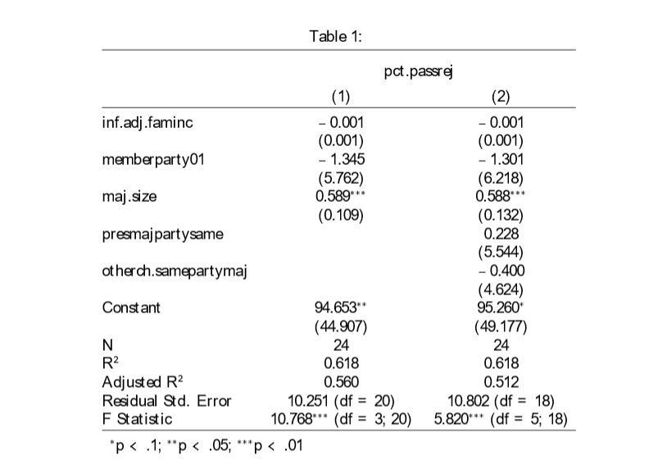
The coefficient for inflation adjusted median family income is -0.001 in both of these models which means that for every dollar increase in a congressional majority’s median family income, the percent of passed legislation decreases by 0.001 percent. In other words, a 1000 dollar increase would be associated with a 1 percentage point drop in percentage of legislation that is passed, which is possibly a significant amount given that the standard deviation of median family income is 4228 dollars. However, this measure is not significant at the 95 percent level of confidence.
The coefficient for the member party variable is -1.3 in both models as well. This is a dichotomous variable with 1 being Republican Party and 0 being the Democratic Party. This coefficient then means that a Republican Party majority is likely to pass 1.3 percent less legislation than their Democratic Party Counterparts holding all else constant. If the president’s party and the majority party in a chamber were the same, then the model would predict that that congressional majority would pass 0.2 percent more legislation. If the majority in one chamber of Congress was the same as in the other chamber, then the model predicts that percentage of legislation passed would decrease by 0.4 points. However, once again, all these coefficients have standard errors that are much larger than the coefficient themselves, meaning that we cannot say that the coefficient’s estimate is statistically different from 0. Additionally, the adjusted R squared in the first model is higher than the adjusted R squared in the second model which adds two additional variables. This indicates that it is unnecessary to include variables accounting for whether the majority party is the same as the president’s party or the majority party of the other chamber of congress.
The only significant coefficient in these models is that for the size of the majority which is significant at a more than 95 percent level of confidence. Based on the coefficient of 0.58 in both models, they predict that as a majority (minority) gains a member, the amount of legislation passed (rejected) will increase by 0.58 percentage points. When digging into my data I discovered that including both percent of rejected and passed legislation inherently causes a strong linear relationship between majority/minority size and percent of legislation that is passed (minorities will always be assigned to the lower percent). This is because I automatically assigned rejected legislation to the minority per my previous reasoning.
For my second regression I fixed this by taking all minority party caucuses out of the data set. In this model I also included an interaction model between median family income and party of the majority. I did this to test the second hypothesis: The effect of constituency income on percent of legislation that is passed in Congress will be moderated by the party of the majority caucus in the chamber.
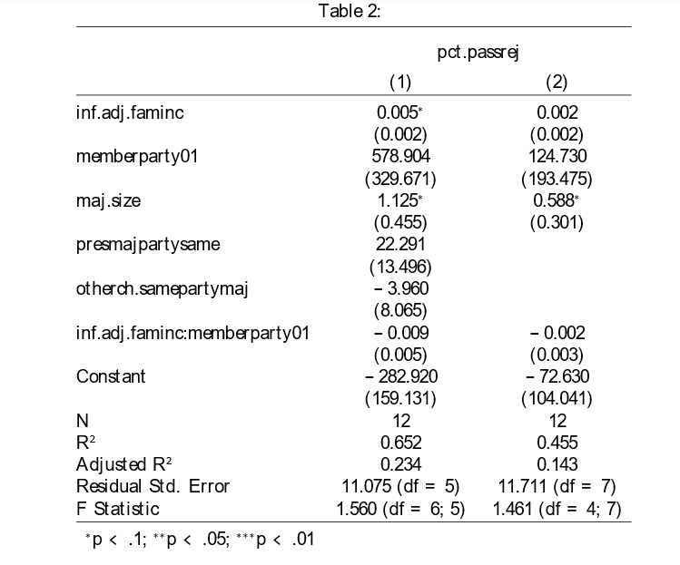
In this model, once again whether the majority party is the same as the president’s party or the majority party of the other chamber of congress is insignificant in predicting percentage of legislation that is passed under a certain majority. However, both size of the majority and median family income are significant in this model, if only at the 90 percent confidence level. This means that there is only a 10 percent chance that we would have observed what we did in the data if there were actually no difference in percentage of legislation passed based on these variables.
The coefficient for median family income was 0.005 which means that for every dollar increase in the average median family income of a congressional majority’s districts, the majority will pass 0.005 percent more legislation, or more significantly, for every 1000 dollar increase, the percentage of legislation passed increases by 5 percent. In addition, the coefficient for the size of the majority is 1.125 which means that for every additional member that adds to the majority, the percentage of legislation passed increases by 1.125 percentage points.
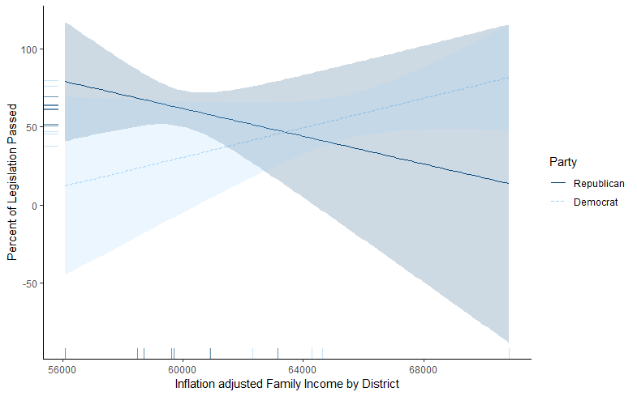
The coefficient for the interaction term was -0.009 which means that being a Republican majority dampens the effect of median family income on percent of legislation passed by 0.009 percentage points, which is a very small number. This number is also insignificant meaning that we do not have enough data to say that there is a real influence of party on the effect between median family income and proportion of legislation that passes. As we can see from the graph above, although the slope of the regression lines for Republicans and Democrats are different, there is no point at which the confidence intervals do not overlap. Therefore, we cannot be certain that there is a real difference between these lines. The data in Table 2 does not prove hypothesis 2, but this data does produce some weak evidence for hypothesis 1. This is because median income is positively correlated with percentage of legislation passed. Although it is not at the 95 percent level of confidence, it is close–the 90 percent level of confidence.
Conclusion
In this observational study, I have attempted to find evidence linking a congressional majority’s median family income per district to the proportion of how much legislation that comes up for a vote is able to pass. I also have studied whether there is a moderating effect of a congressional majority’s party on this relationship. In future research, it would be helpful to study how income of the people represented by Congress affects how Congress voted on bills from different policy areas. For example, income may have a large effect on the passage of economic policy, but not so much on environmental policy. It may also be interesting to break these larger party caucuses down into smaller subunits such as the Congressional Progressive Caucus in the House or the House Freedom Caucus to see what the relationship is between income and their voting behavior.
Unfortunately, due to current limitations on data collected by the Census Bureau, I was only able to collect information for 6 Congressional makeups (the 111th to the 116th). Due in part to this small sample size, it was difficult to get a sense of whether coefficients were statistically significant or not. With more data, these models could probably produce clearer results. There is, however, some relatively weak evidence that median family income leads to a higher proportion of legislation passed.

References
Brunner, Eric. J, Ebonya L. Washington, Eric J. Brunner and Stephen Ross. 2011. “Does less
income mean less representation?” National Bureau of Economic Research (NBER), http://econpapers.repec.org/paper/nbrnberwo/16835.htm
Lewis, Jeffrey B., and Elisabeth R. Gerber. 2004. "Beyond the Median: Voter Preferences,
District Heterogeneity, and Political Representation." Journal of Political Economy 112 (6):1364-83.
Lewis, Jeffrey B., Keith Poole, Howard Rosenthal, Adam Boche, Aaron Rudkin, and Luke
Sonnet (2020). Voteview: Congressional Roll-Call Votes Database. https://voteview.com/
Tausanovitch, Chris. 2016. "Income, Ideology, and Representation." RSF: The Russell Sage
Foundation Journal of the Social Sciences 2 (7) (Nov 1,):33-50.
Ura, Joseph D., and Christopher R. Ellis. 2008. "Income, Preferences, and the Dynamics of
Policy Responsiveness." PS: Political Science and Politics 41 (4) (Oct 1,):785-94.
U.S. Census Bureau; American Community Survey, 2008-18 American Community Survey 1-
Year Estimates, Table S1903; generated by Sean Finnegan; using data.census.gov; (30 April 2020).
Yosef Bhatti, and Robert S. Erikson. 2011. “How Poorly Are the Poor Represented in the U.S.
Senate” from Who Gets Represented? Chapter 8

Appendix
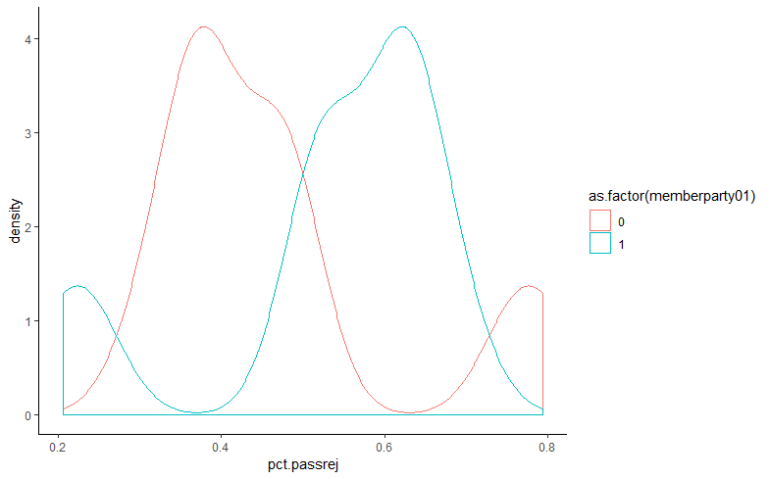
Figure A

Figure B
Interaction Plot with linearity check
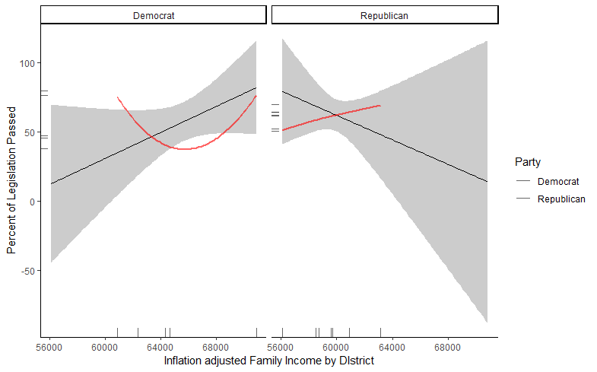
Figures C-F: Various Univariate regression graphs
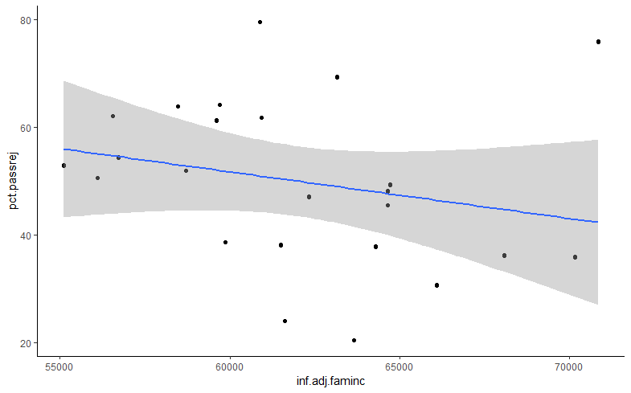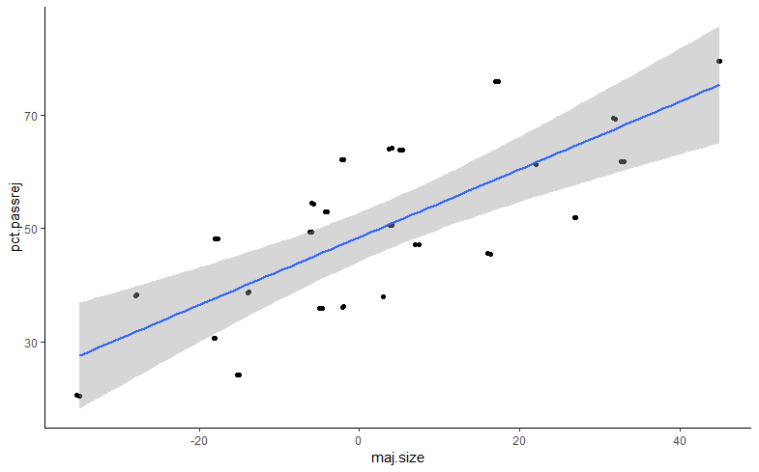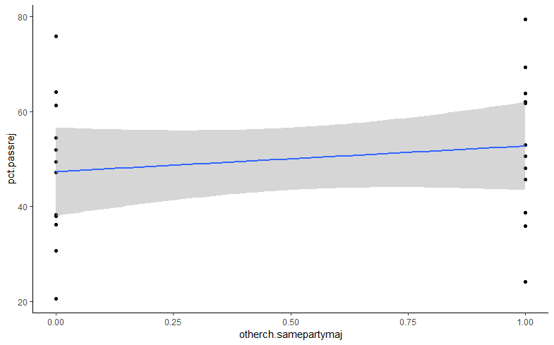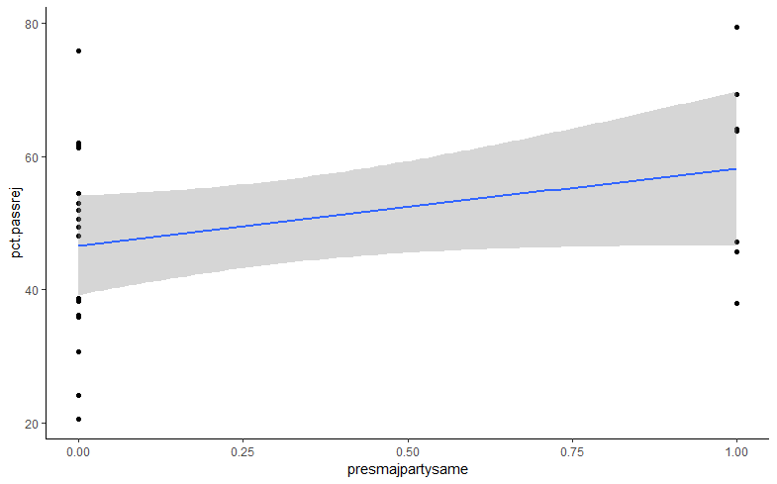

See Appendix figure A

